# Sprint 1

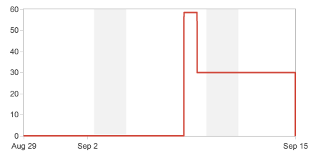

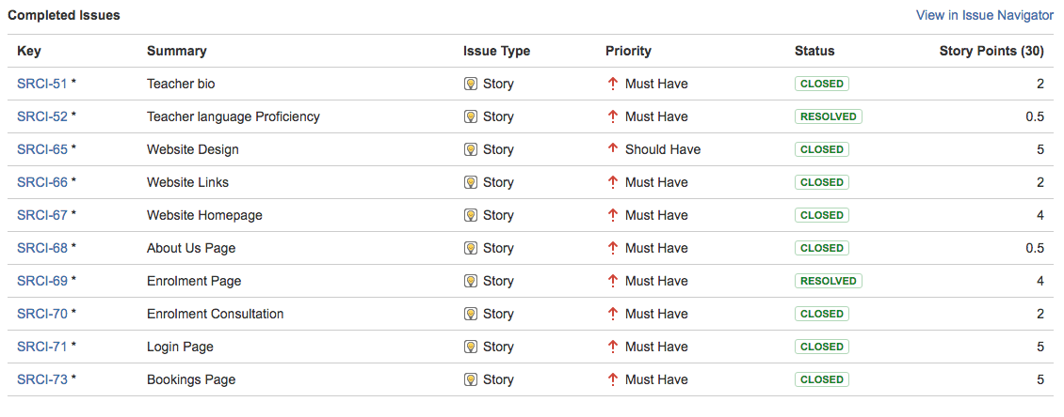

# Sprint 2

# Macintosh HD:Users:Nick:Desktop:sprints:week 2:Screen Shot 2016-09-23 at 6.59.45 PM.png

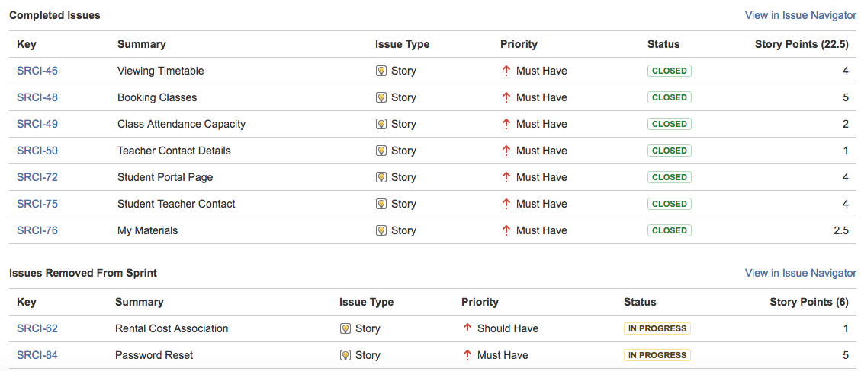

We changed rental cost association and password reset to sprints further down to other sprints. Rental cost association need to be tied into the databases, as they will be storing the costs and information to deal with rental equipment. Password reset also needs to be with the database sprint, as we can’t test if a password reset is working, as we need somewhere to store the original password to begin with. Time line will not add up as we have had technical difficulties attempting to reach jira from home and have only been able to update it when at QUT.

# Sprint 3

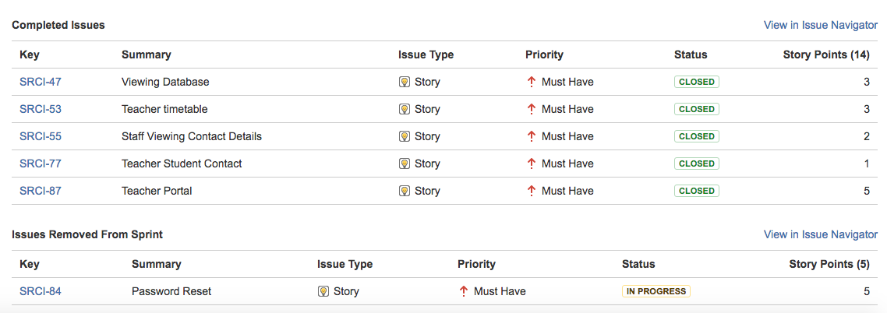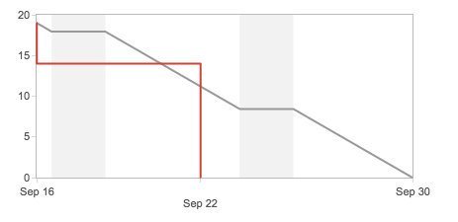

Password reset was pushed back again due to not being able to deal with security issues that the clients had asked of us in the near future. We can’t edit test the password strength and security if we do not have some sort of security feature to protect there website. Jira continue to have technical difficulties and connecting from home so we were only able to update via QUT Internet.

# Sprint 4

# Macintosh HD:Users:Nick:Desktop:sprints:week 4:Screen Shot 2016-09-23 at 7.02.51 PM.png

# Macintosh HD:Users:Nick:Desktop:sprints:week 4:Screen Shot 2016-09-23 at 7.02.58 PM.png

This sprint is still in progress due to other sprints running overtime. Should be finished by end of mid-semester break and be back on track to finish on time. Job application storage was moved from this sprint to the last sprint as we can’t test if the resume storage is working until we have the webpage set up to upload documents to the database.